1. The knowledge base is a dictionary added to a pickle file where each key is one of the ten most common terms, and the values are the sentences in which the terms exist. These sentences are searched through every file and accounts for every sentence the web crawler acquired.

* The top ten terms selected were: bonsai, tree, die, time, japan, soil, water, size, trunk, art. Found by selecting ten useful terms from the most found throughout all the websites.

Below are a few snippets of the knowledge base, see full pickle file for the whole thing.

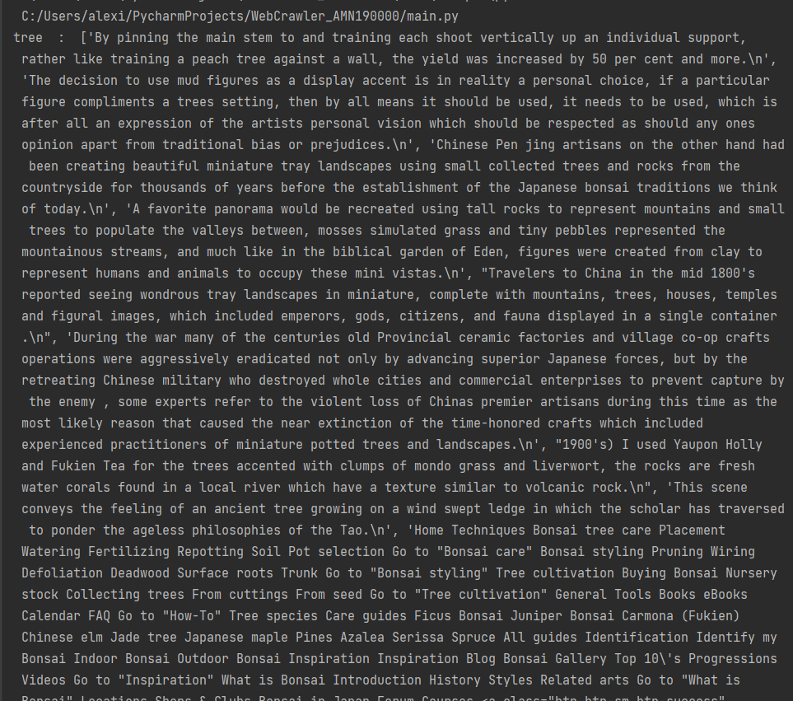

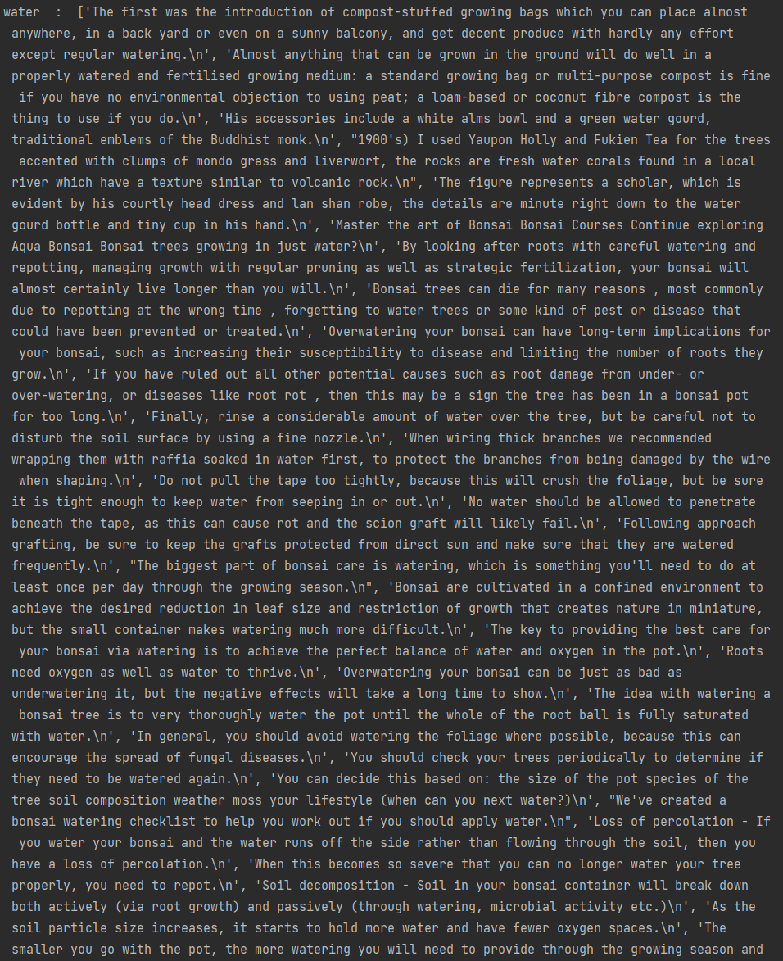

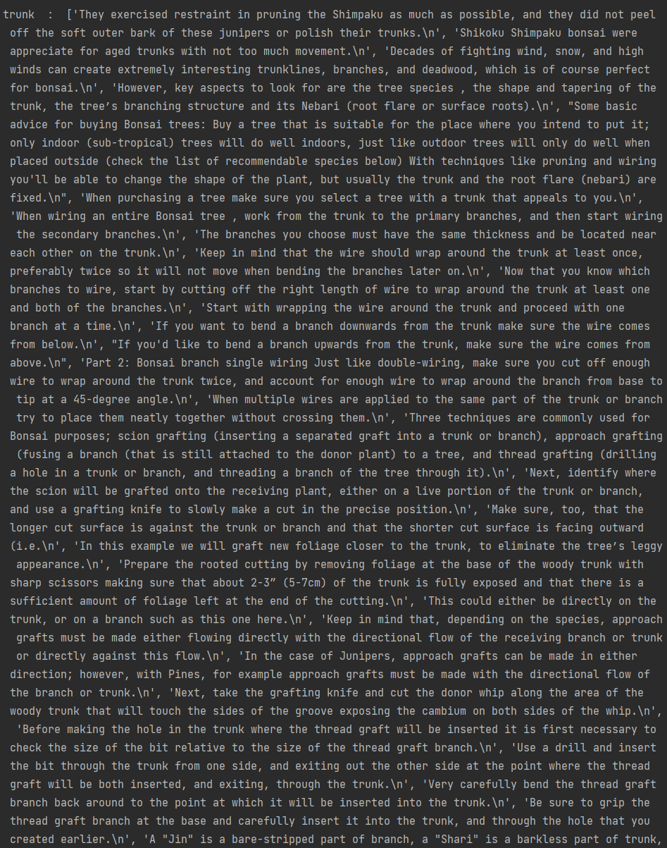

2) Dialog would be interesting to have with the chatbot essentially knowing everything about bonsai trees.

-Hi! Did you know [insert fun fact]. What do you like about bonsai trees?

-I like how they live for so long

-Me too! The longest living bonsai trees are over 1000 years old. Do you have any yourself?

-I have one but I think its dying

-Oh no! What makes you say that?

-Its leaves are turning yellow

-I see, how often do you water it? Bonsai trees should be watered thoroughly when the topsoil is completely dry.

- Okay I will do that many thanks